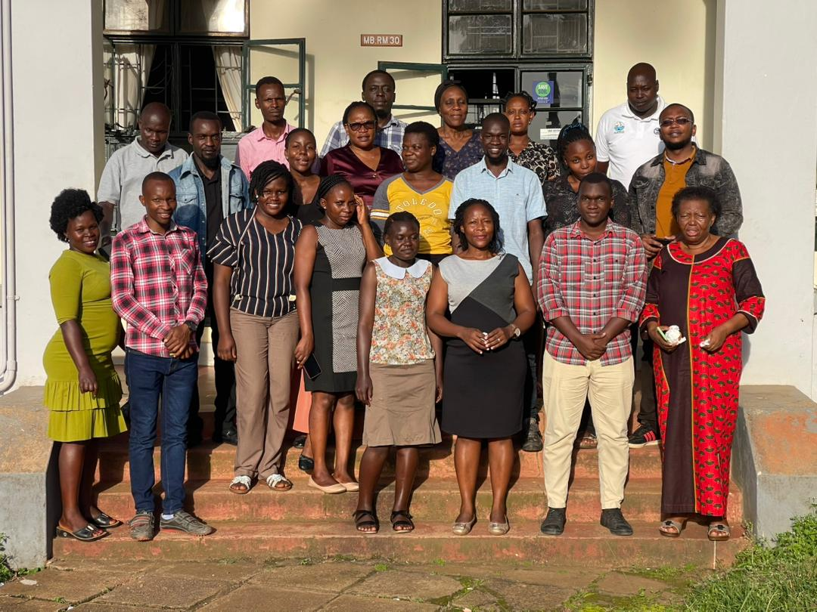
Figure 1 The NARL Climate Change Unit
Scientists at the National Agricultural Research Laboratories (NARL) under the Climate Change Unit are strengthening a digital climate-smart agriculture platform known as the Seasonal Characteristics Tool, or SowSmart App, to help farmers make more accurate planting decisions amid increasing climate variability, in line with the objectives of the Uganda Climate-Smart Agricultural Transformation Project (UCSATP), a World Bank-funded initiative being implemented in 69 districts across Uganda.
During a training of enumerators and regional coordinators held at the NARL Conference Hall on Friday, April 10, 2026, researchers from the Climate Change Unit said the app uses historical weather data and seasonal forecasts generated by the Department of Meteorology to produce planting windows, growing periods, and harvesting windows based on selected crop types and locations.
The training was organised to prepare field teams for nationwide data collection aimed at improving the app’s localisation and predictive capability. According to Dr Everline Komutunga, a senior agronomist at NARL, the upgraded version of the app is also being developed to generate crop water requirements and expected yield projections based on seasonal climate forecasts.
Field teams are expected to collect GPS coordinates from farming communities across different agroecological zones in Uganda. The coordinates will guide the acquisition of satellite-derived climatic data that will supplement existing weather observations and strengthen the app’s ability to generate more localised advisories.
Dr Everline Komutunga said the additional climate and geographic data will be fed into the SowSmart App to improve forecasting accuracy and help the platform achieve planting window predictions with at least 50 per cent accuracy.
The initiative forms part of the Uganda Climate-Smart Agricultural Transformation Project (UCSATP), a government-led agricultural modernisation program implemented by the Ministry of Agriculture, Animal Industry and Fisheries (MAAIF) with funding from the World Bank to strengthen agricultural resilience against climate change.
The UCSATP, which is currently being implemented in 69 districts nationwide, focuses on climate-smart agricultural research, digital agro-climatic information systems, climate-resilient technologies, and value-chain development aimed at improving productivity and reducing climate-related agricultural losses.
Dr Everline Komutunga says the SowSmart App directly supports these objectives by converting complex meteorological and climate data into practical advisories that farmers can use for decision-making.
The app is expected to support several priority value chains under UCSATP, including maize, beans, coffee, bananas, rice, cassava, and oilseeds, all of which are increasingly vulnerable to erratic rainfall patterns, prolonged dry spells, and false rainfall onset caused by climate change.
Researchers noted that traditional planting calendars are becoming less reliable due to shifting weather patterns, making data-driven advisory systems increasingly important for farmers who depend on rain-fed agriculture.
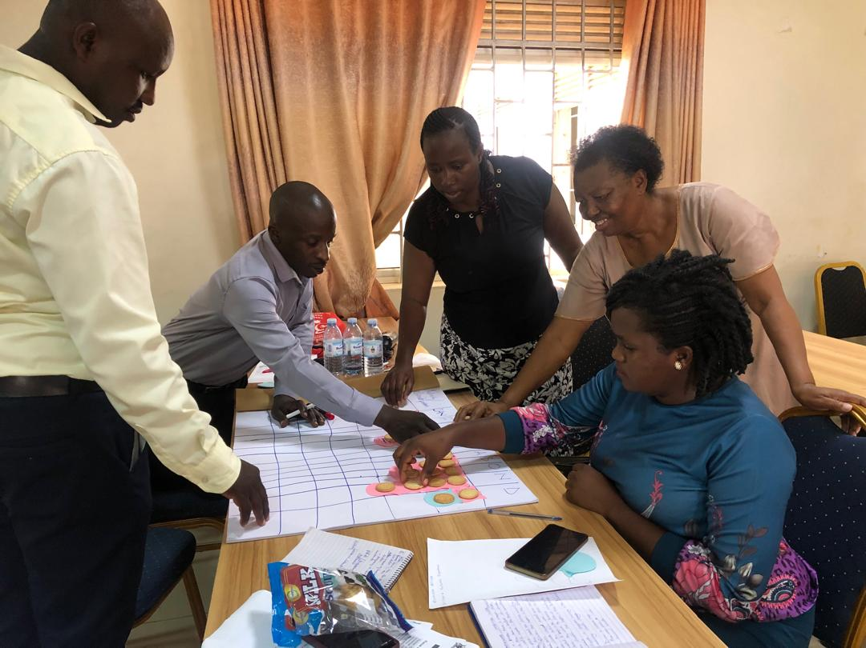
Figure 2: One of the groups during the training
“The goal is to move farmers from relying on guesswork to relying on scientifically generated planting advisories,” one researcher explained during the training session.
The SowSmart platform combines meteorological forecasts, historical climate records, field-based agricultural research, and satellite climatic information to improve decision-making at the farm level. Scientists believe the integration of localised GPS-based data will significantly improve the system’s precision across different regions of Uganda.
Enumerators and regional coordinators participating in the training were equipped with skills in GPS mapping, field data collection, and reporting procedures to ensure that the information gathered from farming communities is accurate and reliable.
According to the Climate Change Unit, the project reflects Uganda’s growing shift toward digital agriculture and predictive farming systems capable of helping farmers adapt to climate uncertainty while improving agricultural productivity and resilience.
By integrating climate research, satellite technology, and localised weather intelligence, the SowSmart App is expected to become an important tool in supporting climate-smart agriculture and strengthening food security under the UCSATP framework.

